

**MERN PROJECT REPORT**

**BLOGGING WEBSITE**

**Submitted By:**

|  |
| --- |
| NAME:- Aditya Ranjan Sahu NAME:-Durga Prasad Patra  SIC:- 21BCSB78 SIC:- 21BCSF16  SEC:- B2 SEC:- B1  ROLL-NO: 20 ROLL-NO:-24  NAME:- Om Prakash Behera NAME:-L Manoj Kumar  SIC:- 21BCSD05 SIC:- 21BCSD03  SEC:- B1 SEC:-B2  ROLL-NO: 30 ROLL-NO:- 31 |

**GUIDED BY:**

Mr Surajit das

**PROJECT DESCRIPTION**

Blogging Platform is a web application designed to provide users with a platform to create, publish and share their thoughts. In this Website we can create blogs and post it . There is a two type of users one is Reader who can only view the blog and the other Author who can read and also create the blogs. This website offers a modern , responsive, and user-friendly interface for both readers and authors.Authentication is handled through Json Web Token for enhanced security. Only Authorized users can create the blogs and publish. Users can view , edit and delete their own blogs from the dashboard. Blogs have categories You can post the blogs according to your categories(Sports, news, etc..).

**Technologies used:**

**Frontend:** React, HTML5, CSS, JAVASCRIPT.

**Backend:** Node.js, Express.js , MongoDB

**Authentication:** JWT, Cookies

**Addition Tools:** Postman, Cloudinary

**OBJECTIVES**

* The primary Objective of the MERN blogging website is to offer users a platform to express themselves freely
* One of the key objectives is to promote knowledge sharing and learning. By providing a diverse range of content across different topics and interests.
* The Website seeks to foster a sense of community among its users by encouraging interaction, collaboration, and discussion.
* The website strives to provide an intuitive and user-friendly experience for both writers and readers.This includes features such as easy navigation, response design and personalized.
* It is to empower content creators by providing them with tools and resources to create high-quality, engaging content.

**BLOGGING WEBSITE**

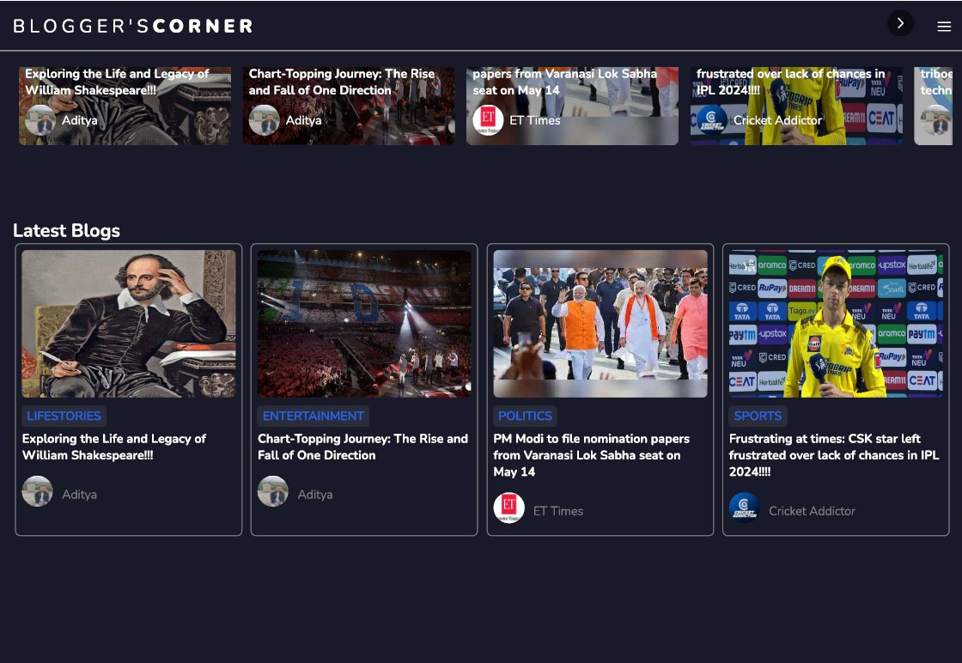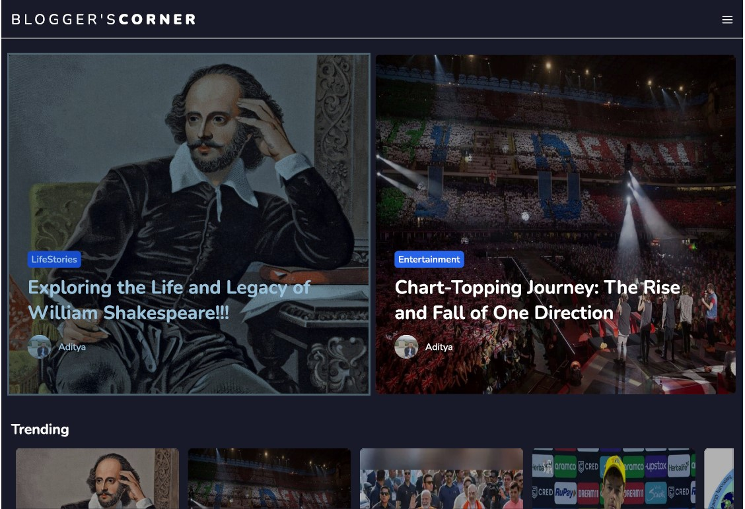HOME PAGE:

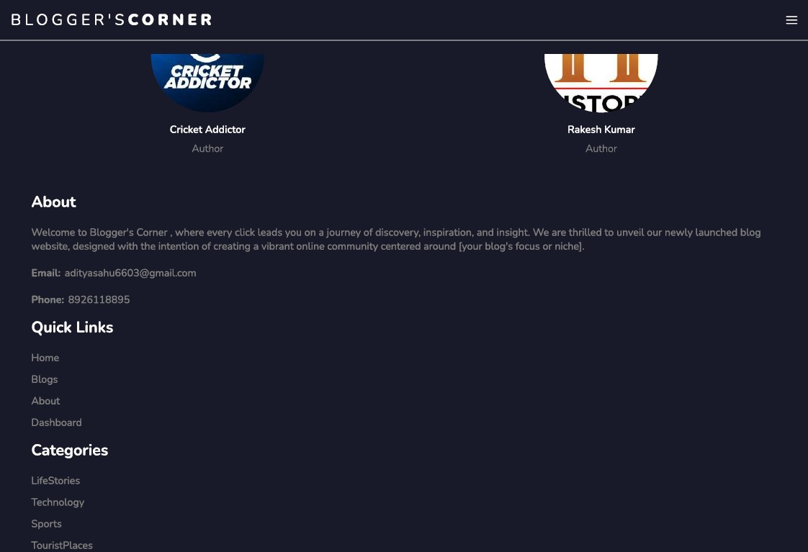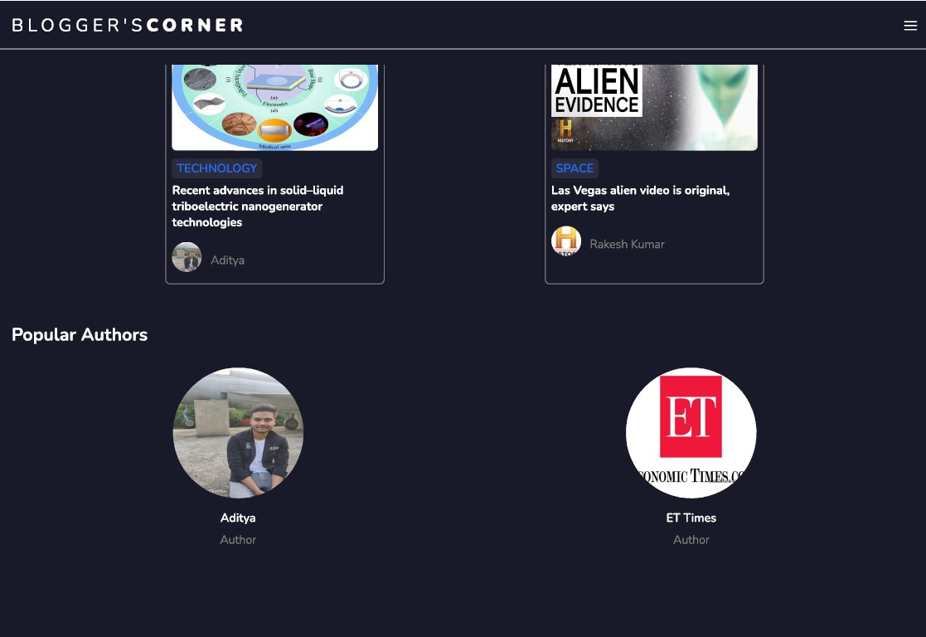

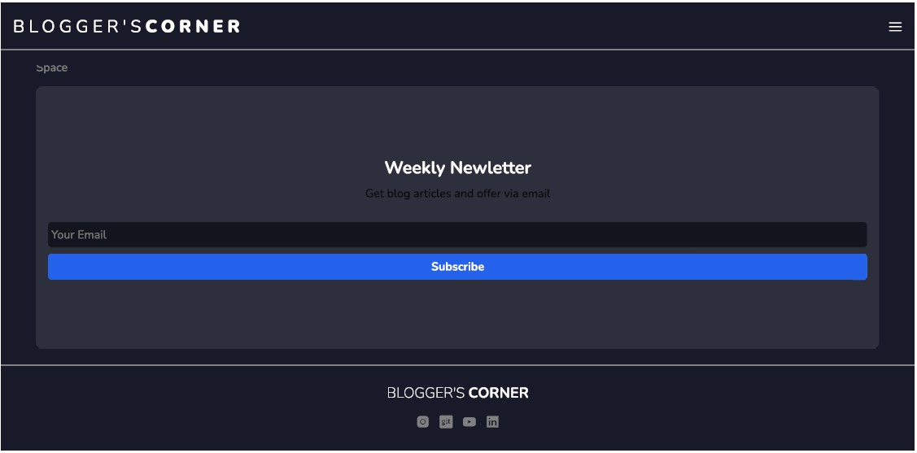

**LOGIN PAGE:**

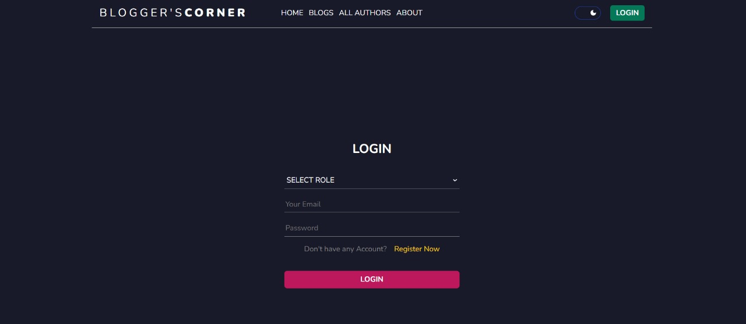

REGISTER: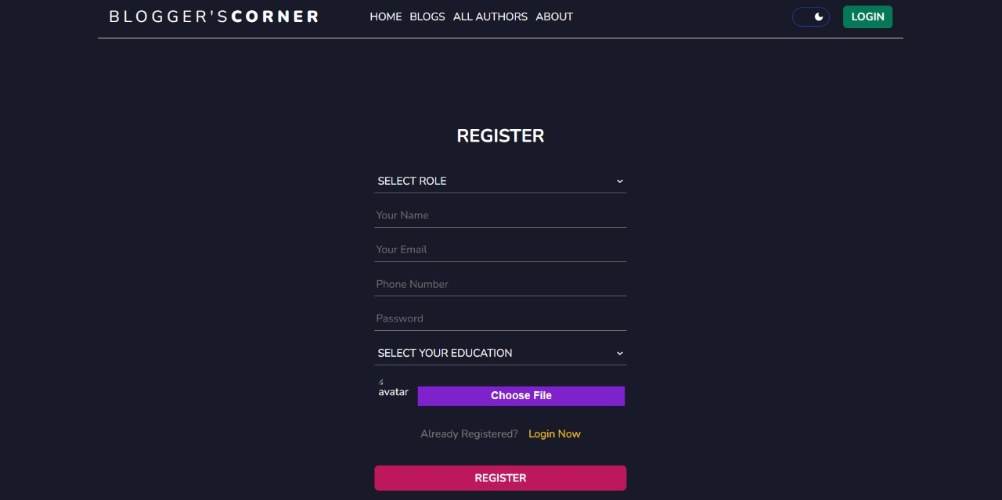

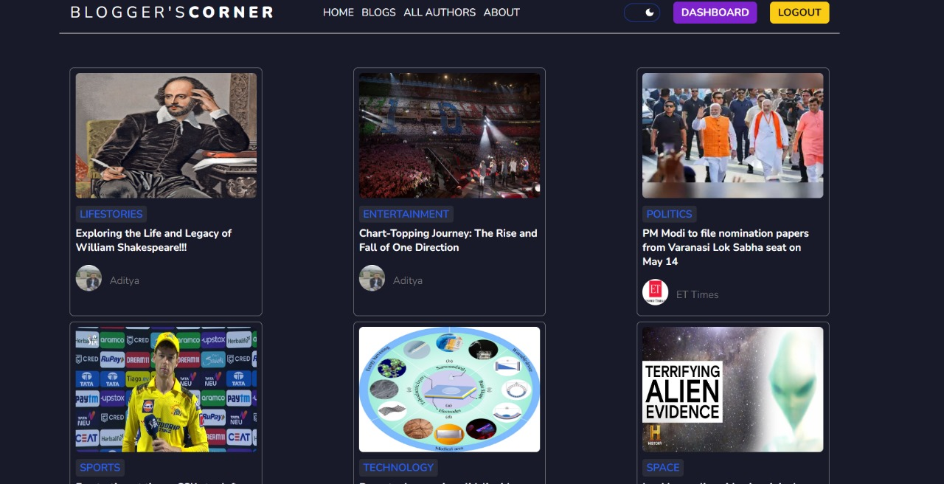**BLOG’S SECTION:**

**ALL AUTHORS:**



**ABOUT PAGE:**

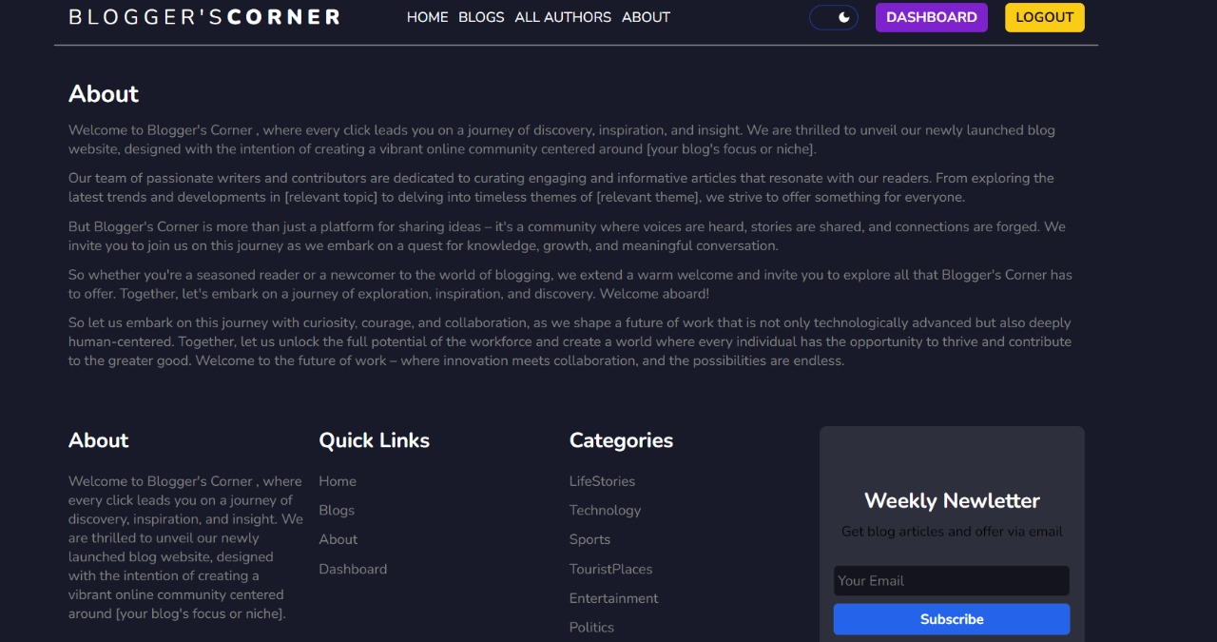

**UPDATE AND DELETE:**

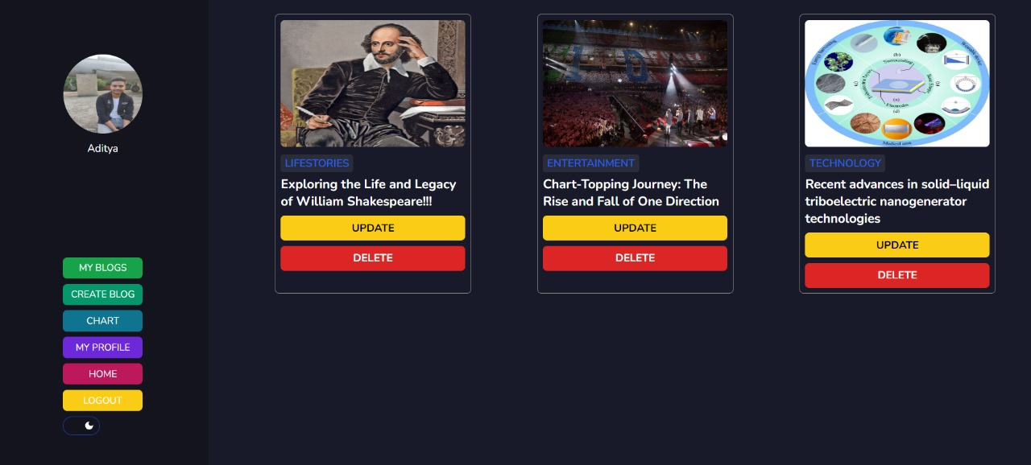

**CREATING BLOG:**

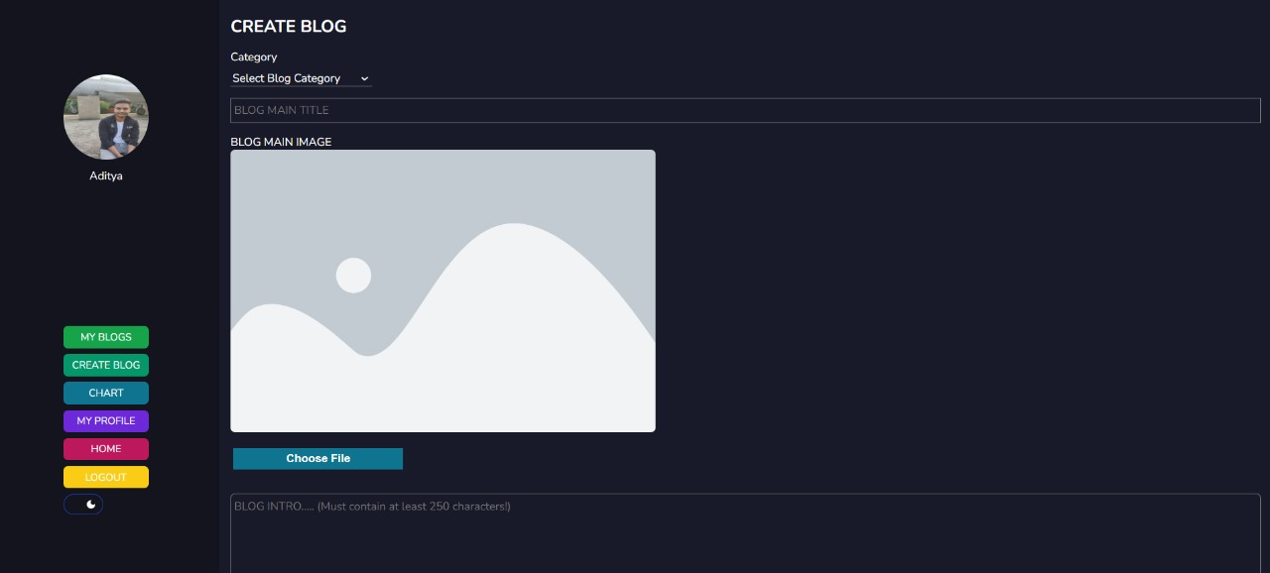

**CHART:**

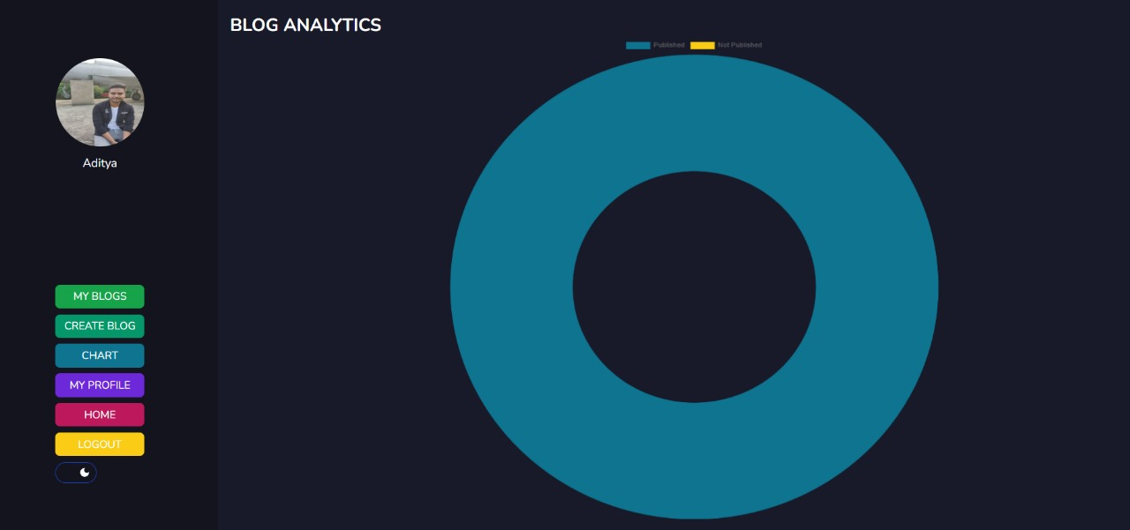

**MY PROFILE:**

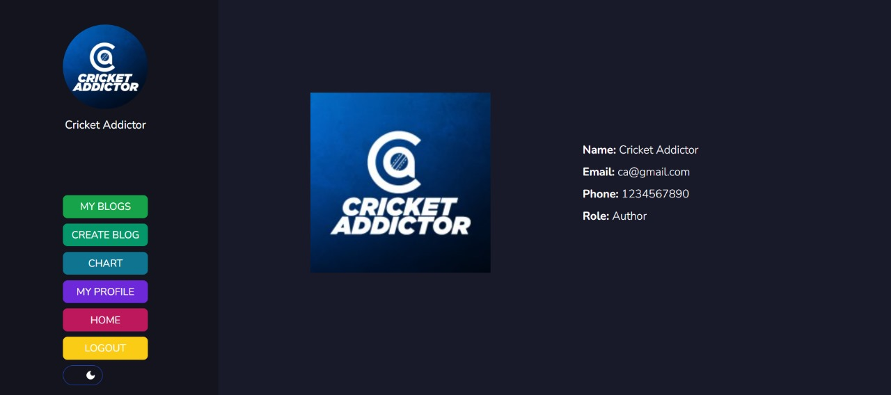

**POST MAN**

REGISTER:

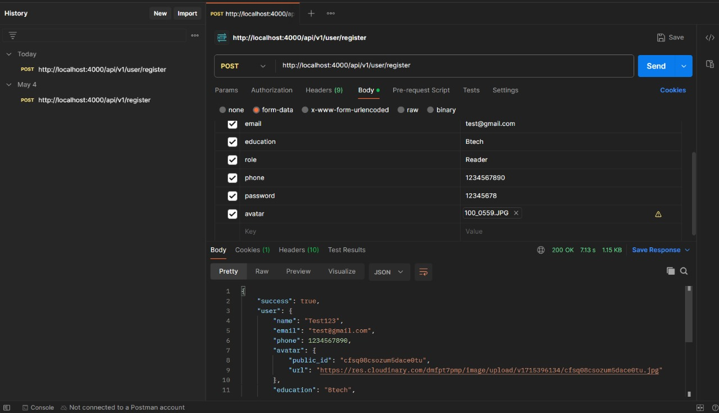

LOGIN:

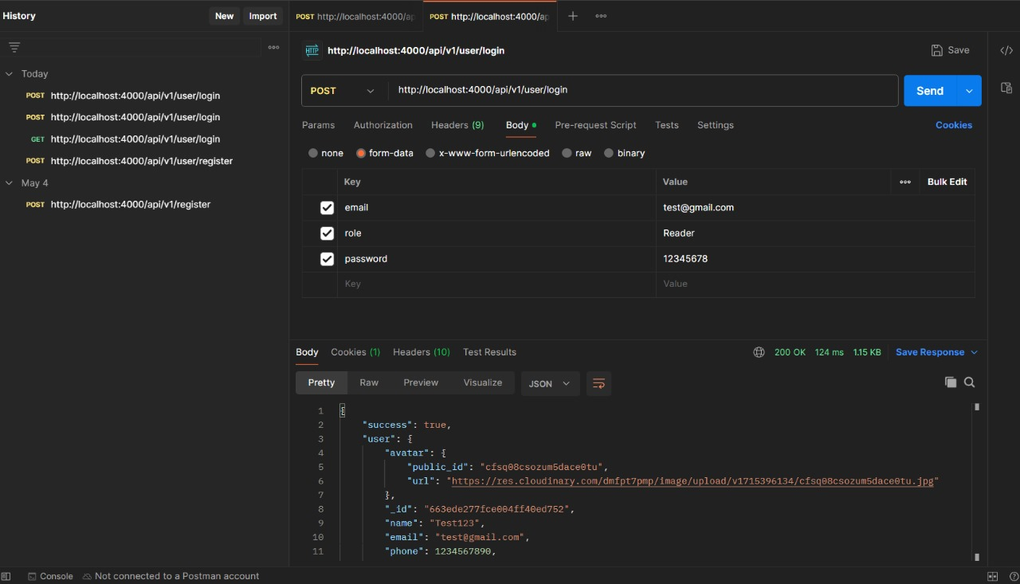

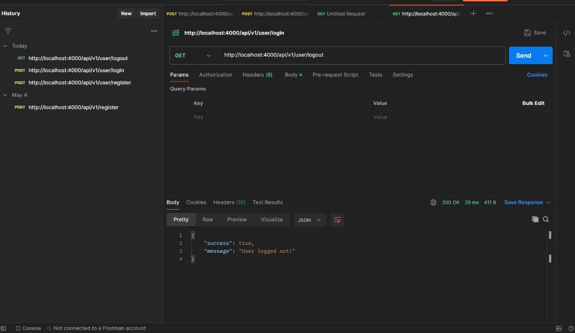LOGOUT:

GET ALL BLOGS:

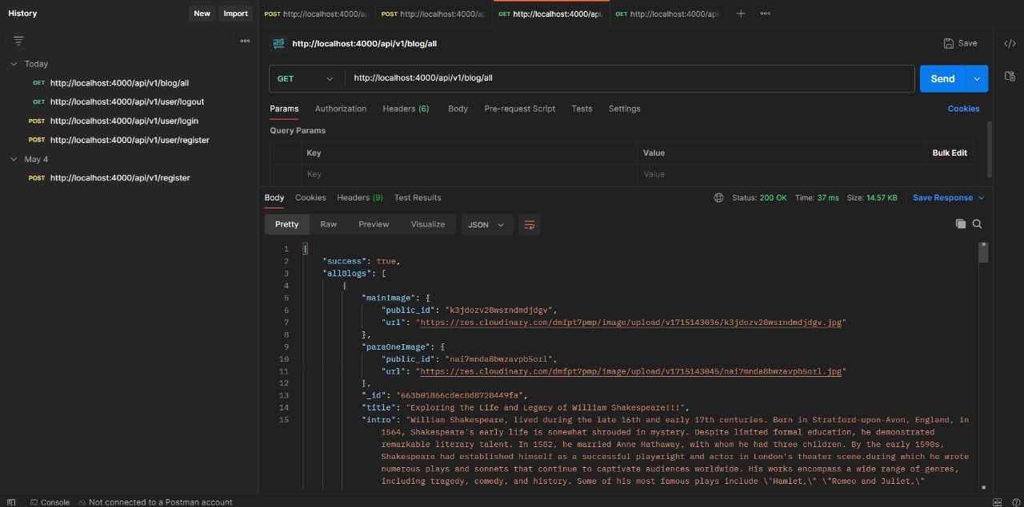

**CODE SNIPPETS**

**BACKEND:**

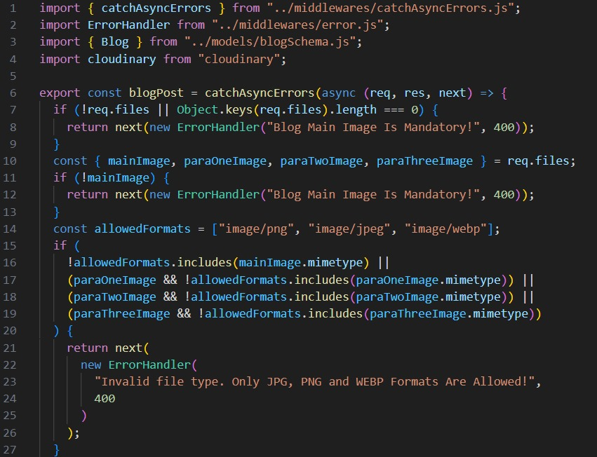Blog Controller:

DATABASE: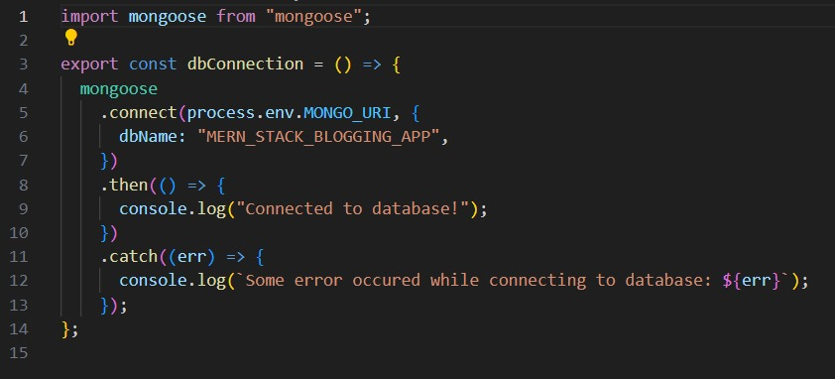

USER CONTROLLER:

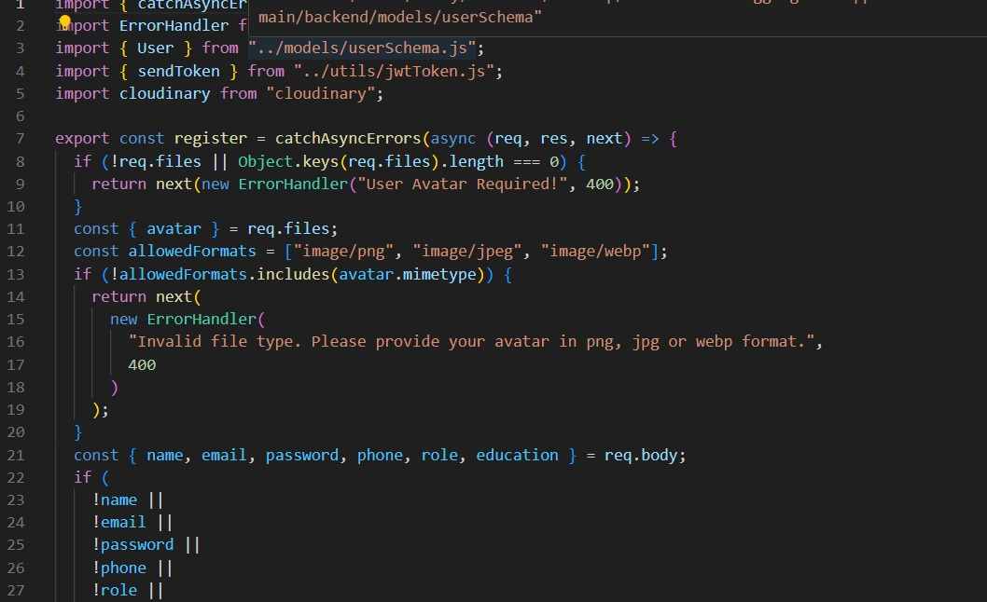

**MIDDLEWARE:**

Auth.js:

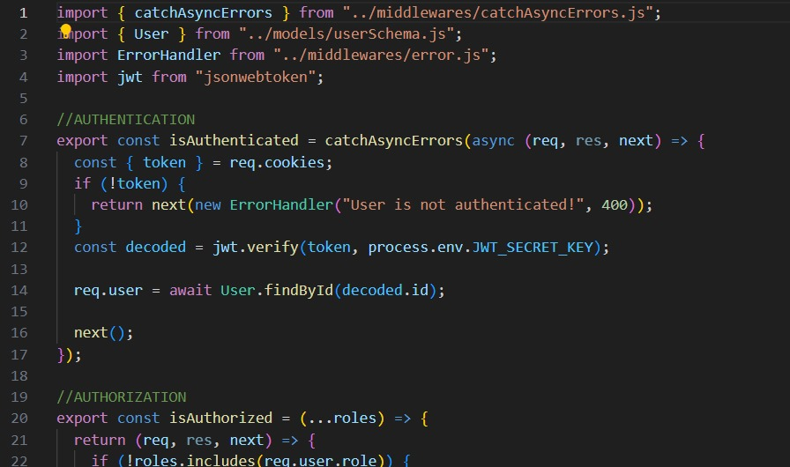

catchAsyncErrors:

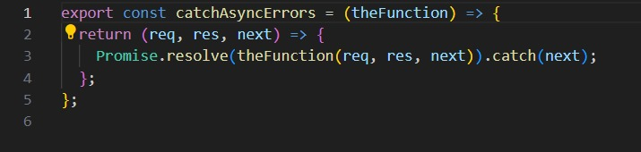

Errors.js:

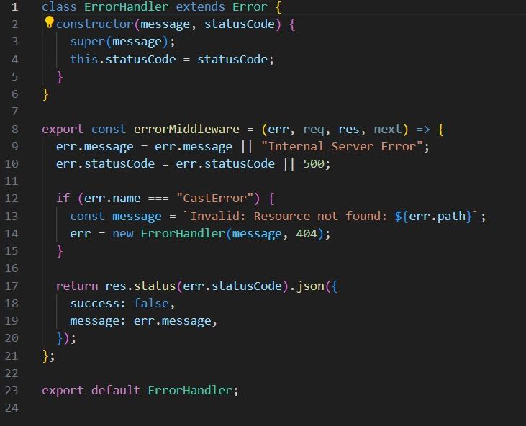

**MODELS:**

Blog Schema: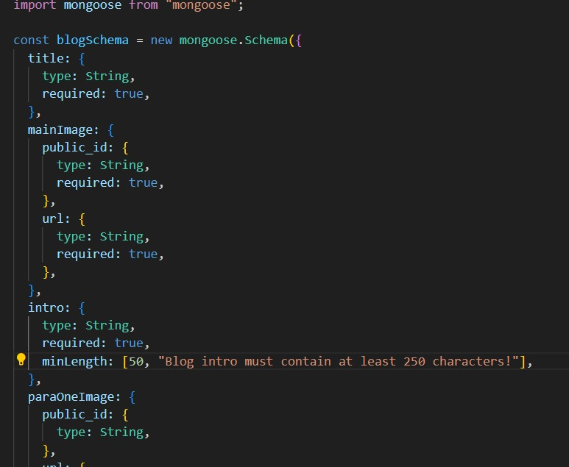

User Schema:

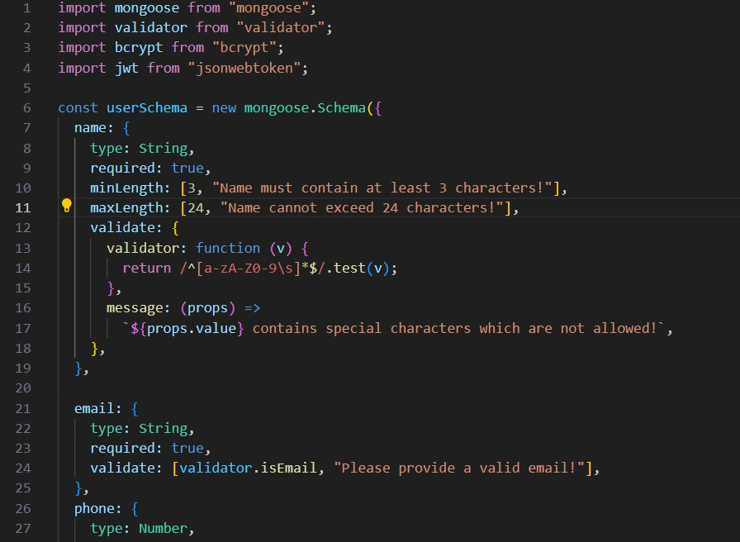

**UTILS:**

Jwt Token:

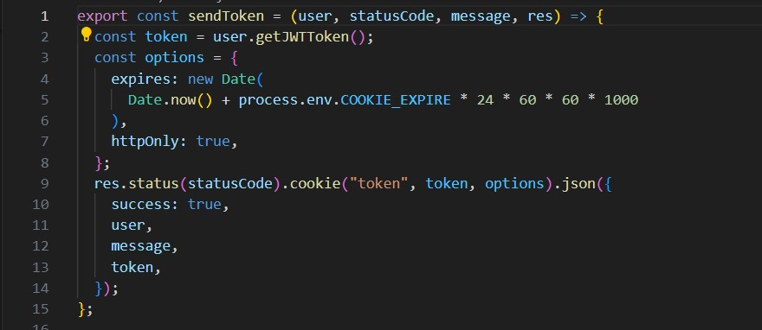

App.js:

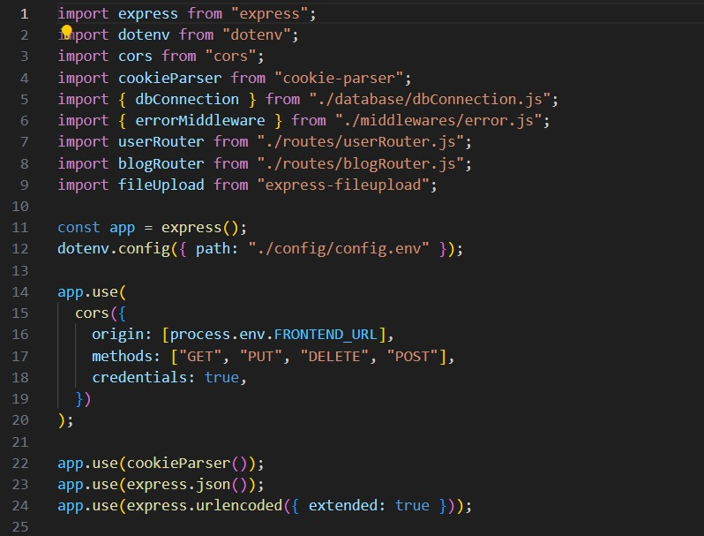

Server.js:

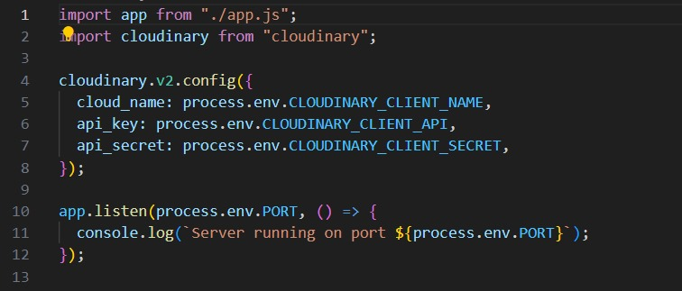

**FRONTEND:**

**LAYOUT**

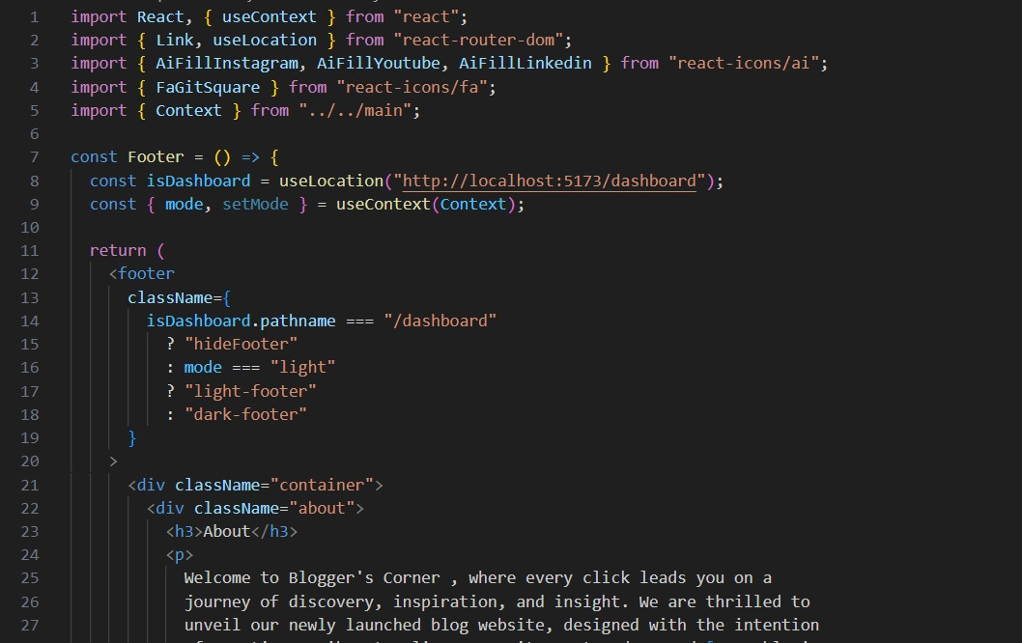 Footer.jsx:

Navbar.jsx:

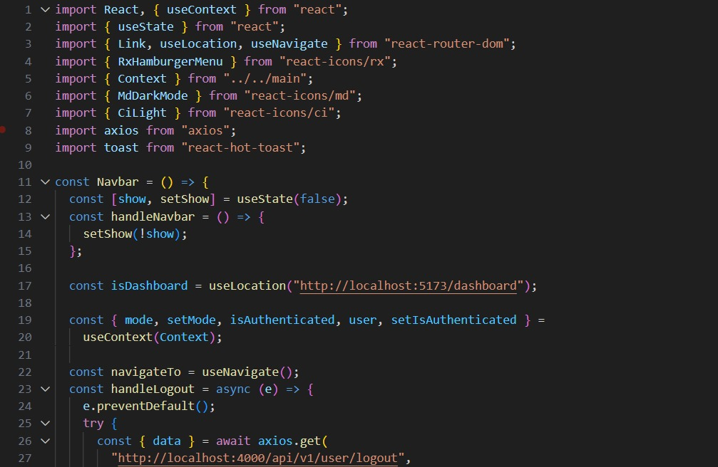

Sidebar.jsx:

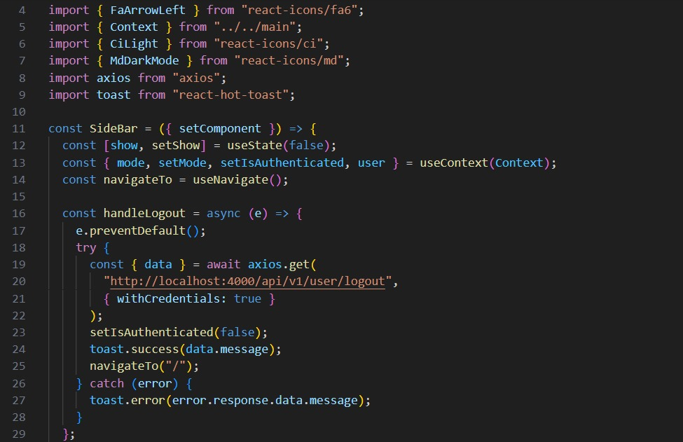

**Mini components:**

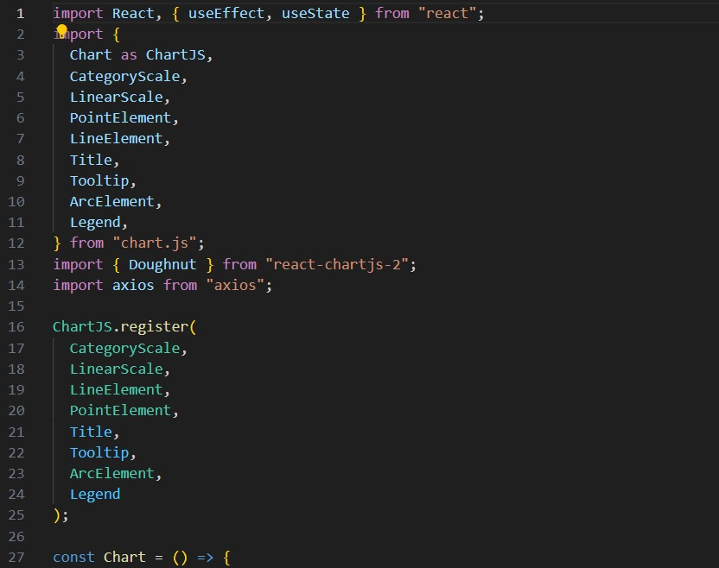 chart.jsx:

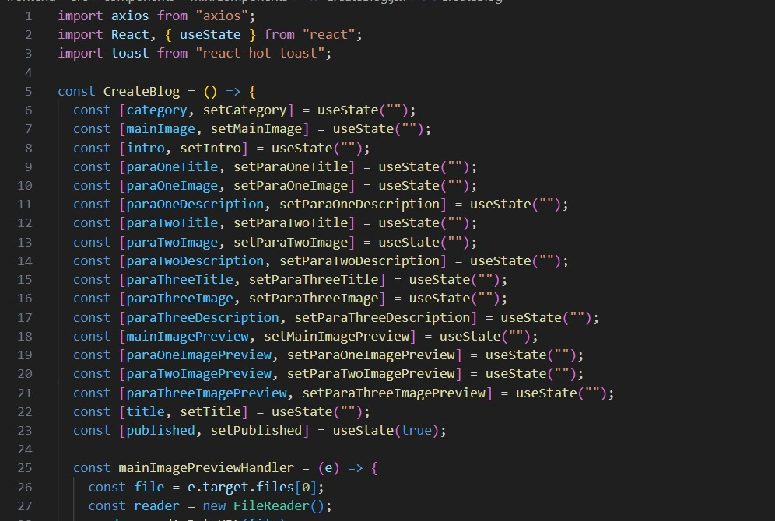CreateBlog.jsx:

HeroSection.jsx:

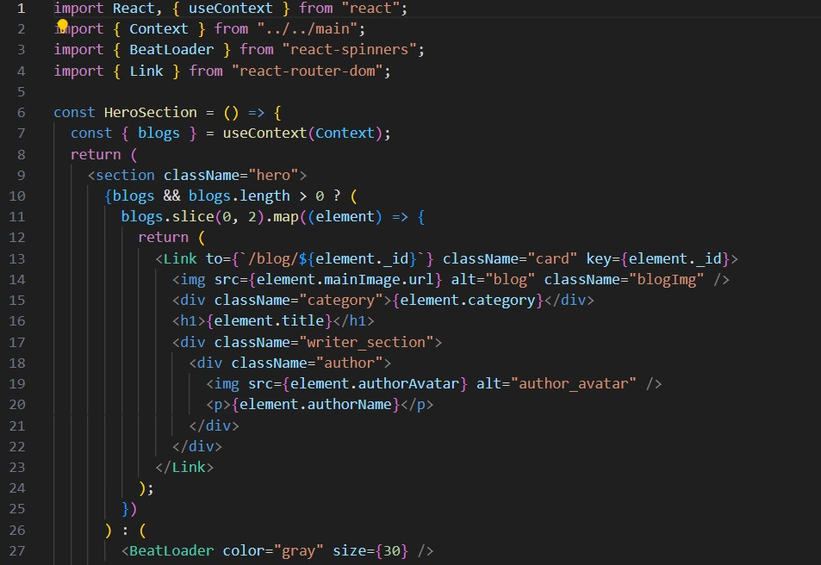

Latestblog.jsx:

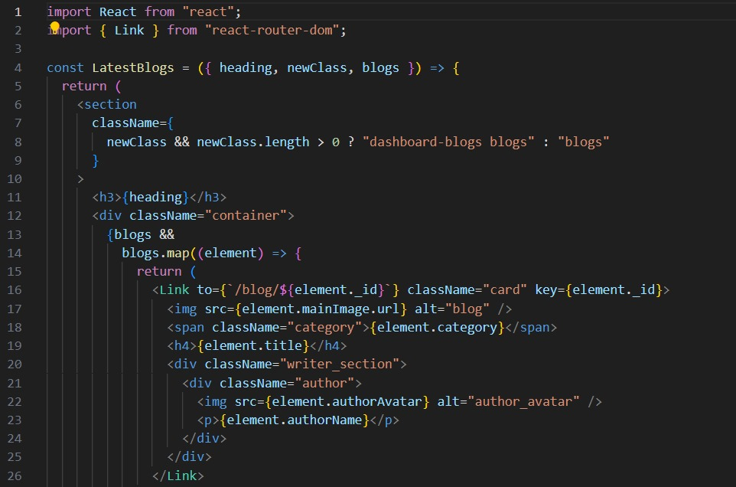

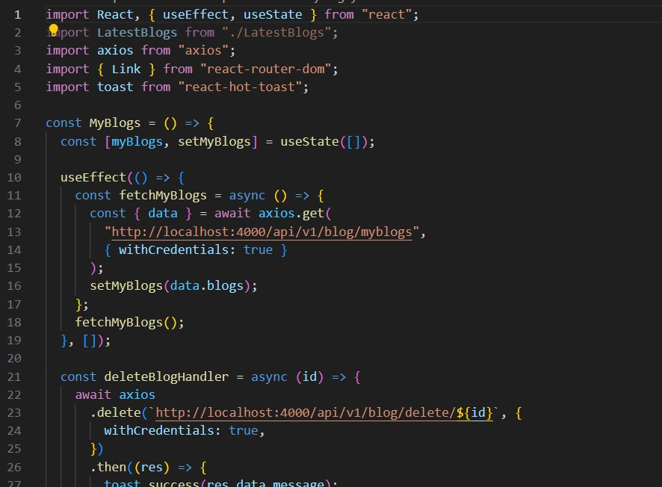My blogs.jsx:

My Profile.jsx:

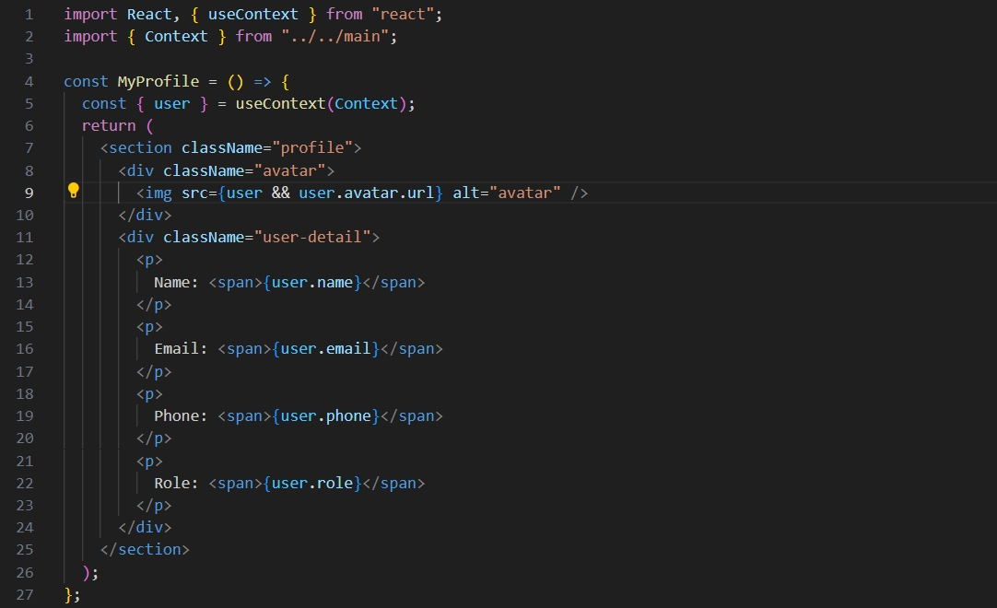

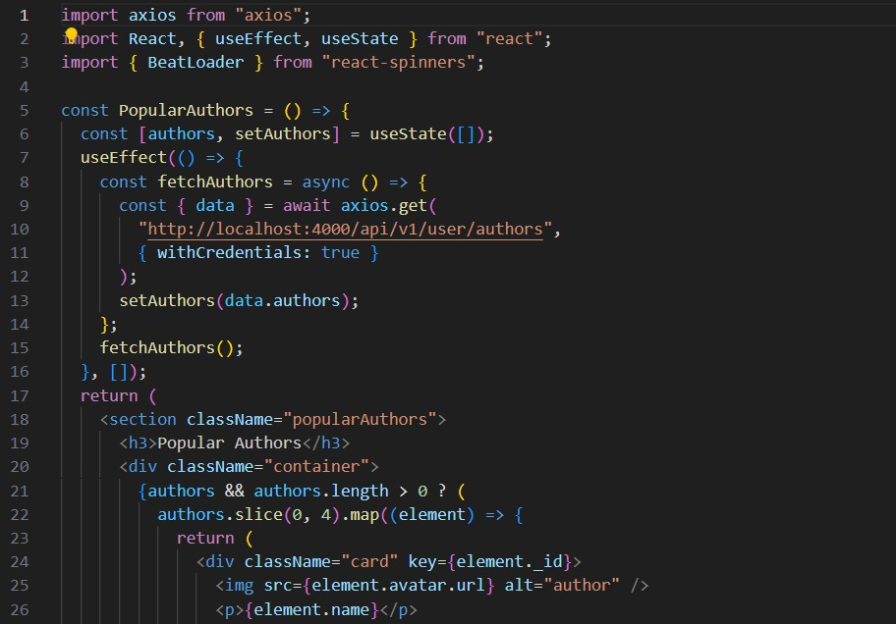Popular Authors.jsx

Trending Blogs.jsx:

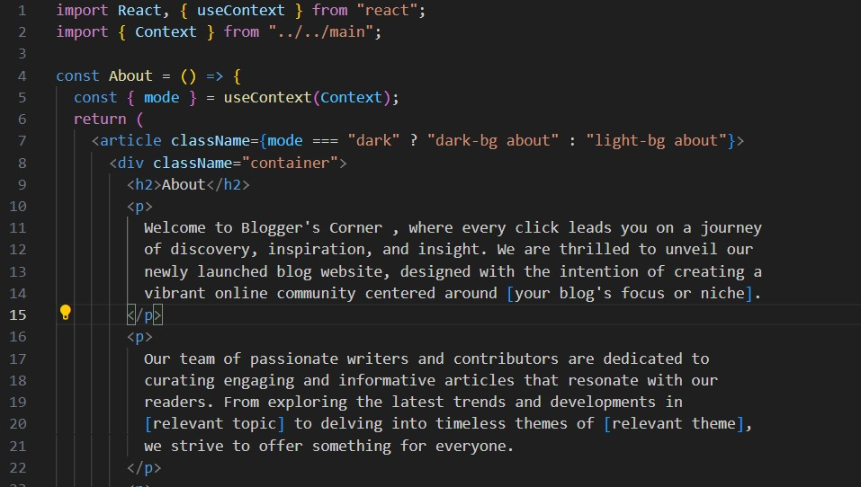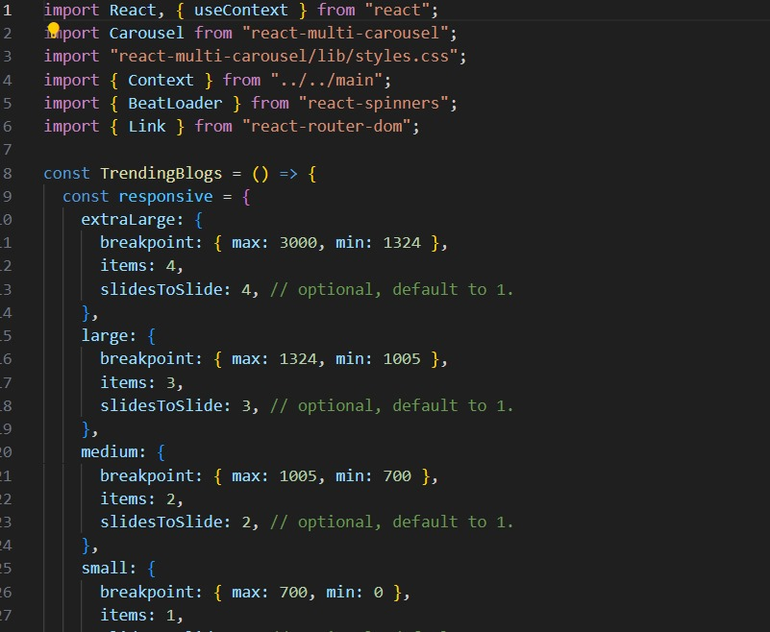

About.jsx:

All Authors.jsx:

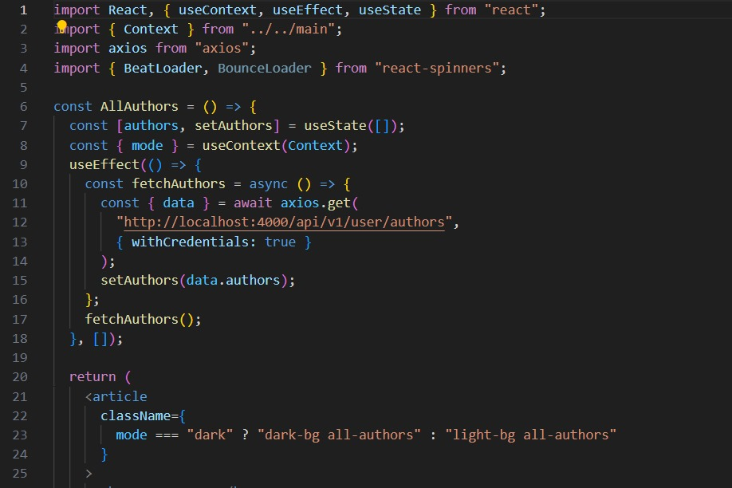

Blogs.jsx:

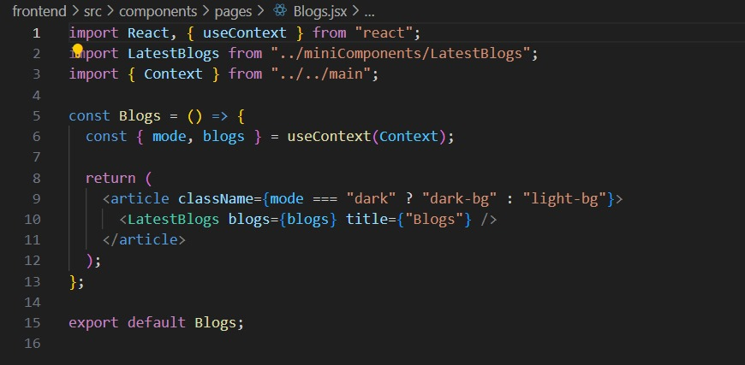

Dashboard.jsx:

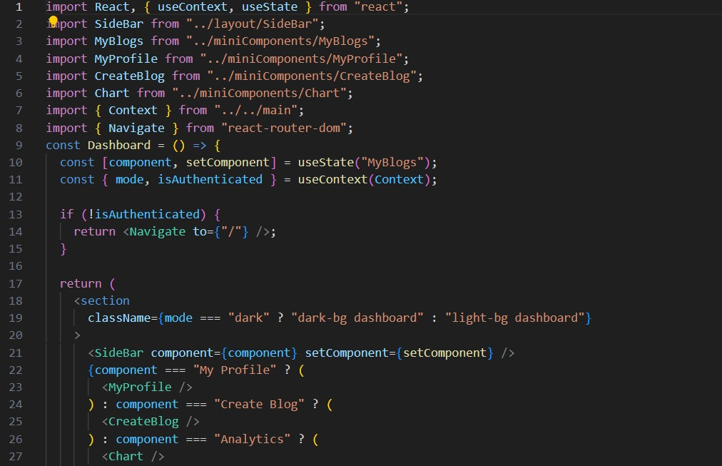

Home.jsx:

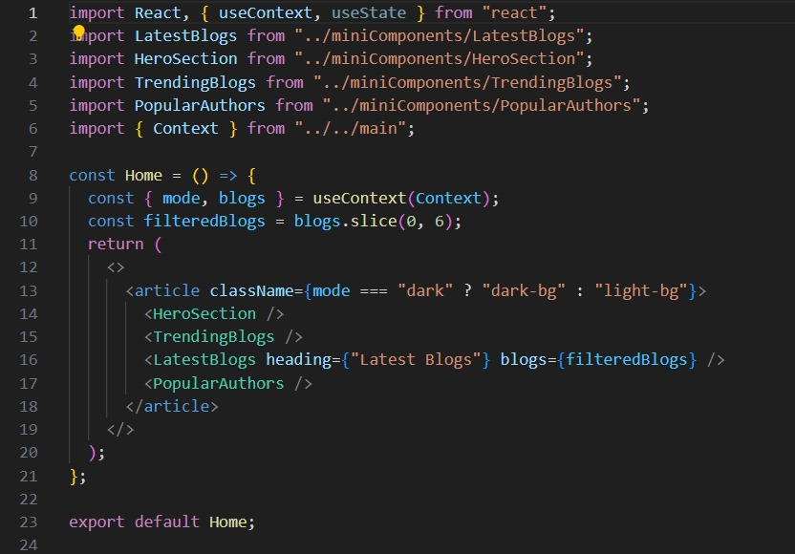

Login.jsx:

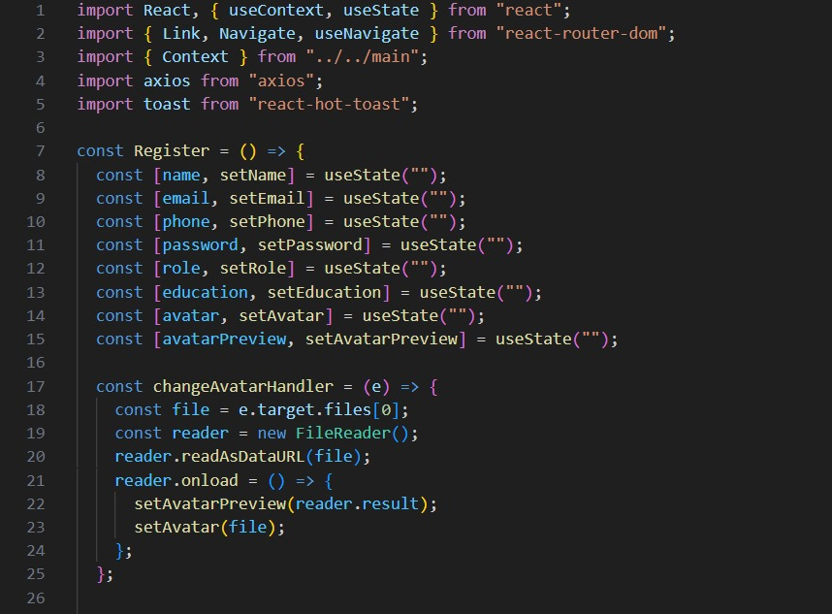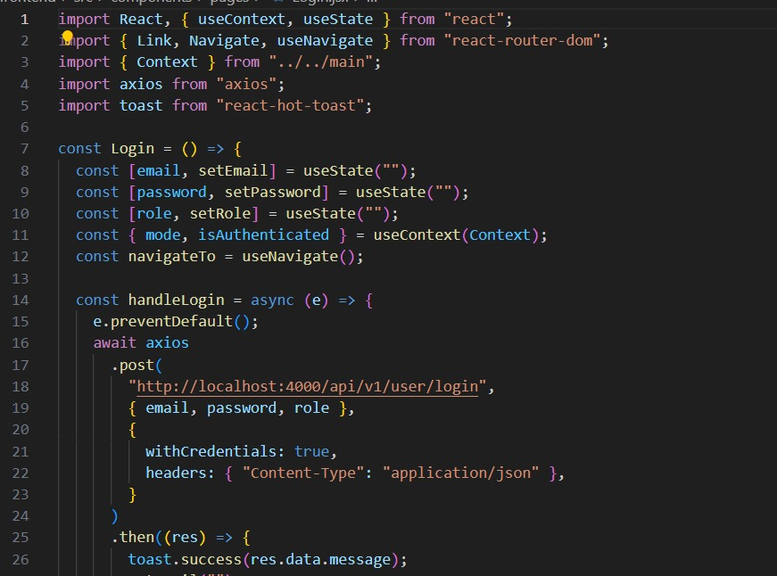

register.jsx:

Single Blog.jsx:

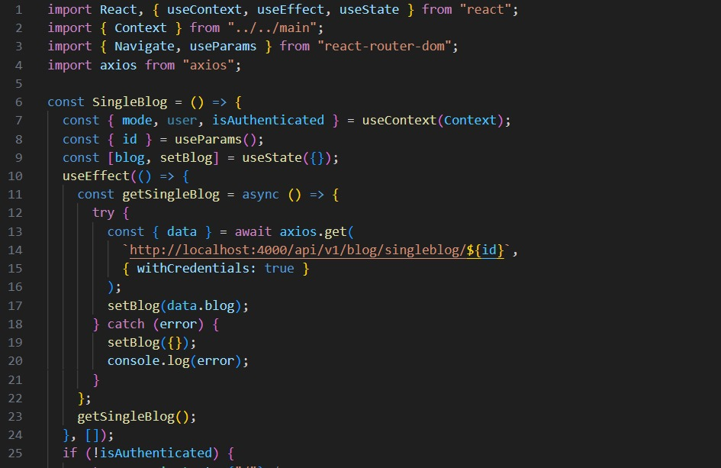

Update Blog.jsx:

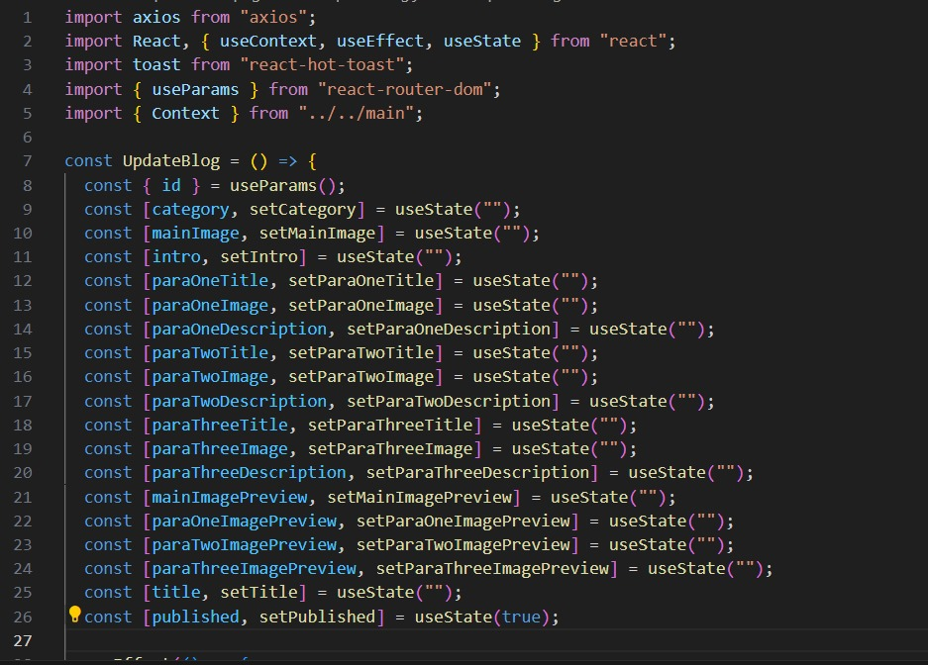

App.css:

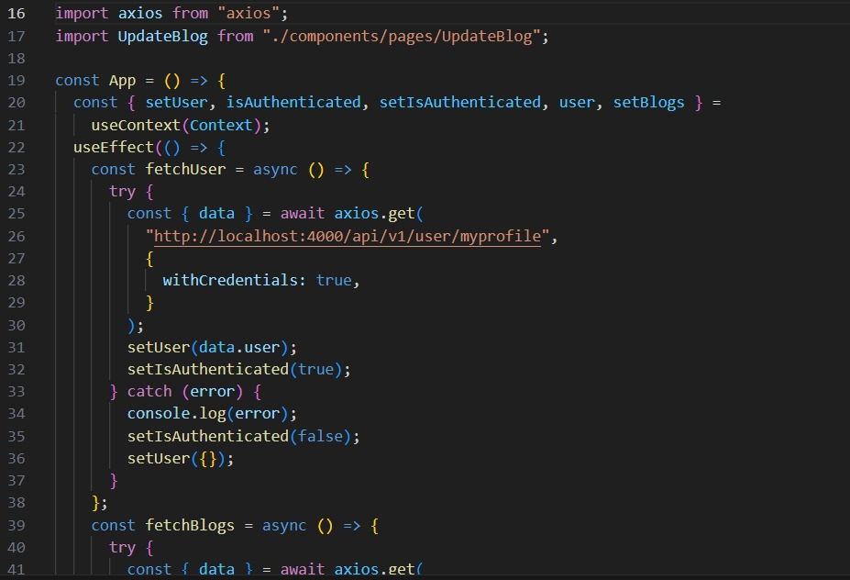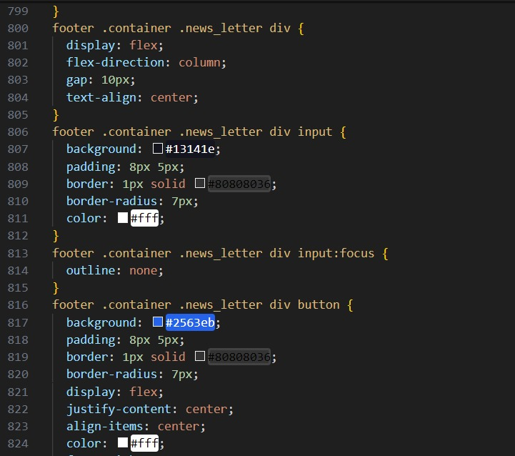

App.jsx:

Main.jsx:

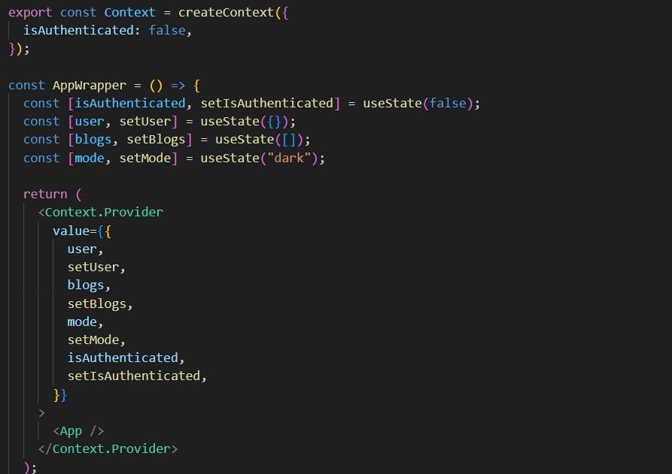

Index.html:

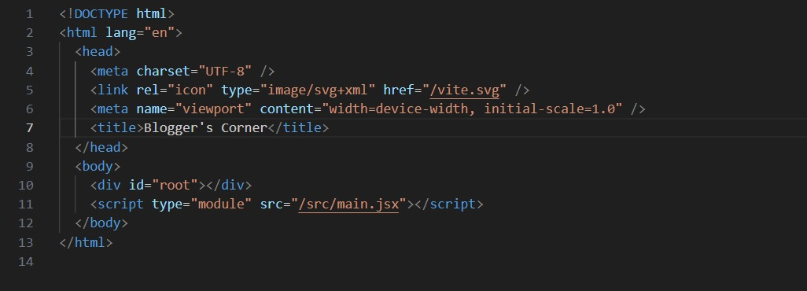

Mongo DB:

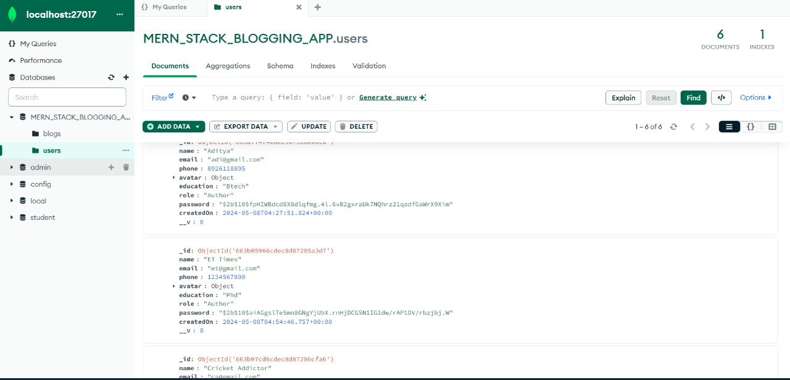

**CONCLUSION**

The MERN Blogging Platform aims to provide an inituitive and feature-which blogging experience for both writers and readers. With its robust functionality, responsive design, and potentiall for future enhancements, it stands as a versatile solution for individuals and businesses looking to establish an online presence through content creation and dissemination

Through its user-friendly interface and comprehensive feature set, the platform empowers writers to craft compelling content with ease. From drafting and editing to publishing and sharing, every aspect of the blogging process is streamlined to enhance productivity and creativity.